

**DolphinGroup**

Project Clousre Report

July, 2021

SMARTAGRI

EXECUTIVE SUMMARY

**Problem**

* Lack of high technology applications
* Product yields are not effective and synchronous
* Weak connection between customers, farmers and companies

**Solution:**

A hybrid-app have features that:

* Connects parties in Agribusiness
* Update high-tech agricultural news
* Find investors

**Target audience:**

* Gender: All gender
* Age: Gen X – Gen Z
* Hobbies: Agriculture, Investment.

**Highlights:**

* Investment feature
* E-com service
* Sharing knowledge forum

**Gains:** Gain experience to work in a short project

LETTER OF TRANSMITTAL

July 20, 2021

Le Thi Thu Trang

Dolphin Team.

1011, Le Van Viet Street, Long Thanh My Ward, Thu Duc City, Ho Chi Minh City

Ho Chi Minh, 71216

Hoang Duc Huy

CEO - SSG103 Inc

Block E2a-7, D1 Street, HCMC Hi-tech Park, Long Thanh My Ward, Thu Duc City, Ho Chi Minh City

Ho Chi Minh, 12345

Dear Mr.Hoang:

Within the attached report and document, you will find information about Smart Agriculture application and its components.

This document is a summary of the Smart Agriculture application, a project that helps the farmers to obtain better information about their farms and market states. Using mobile applications as our main platform, we aim for a large number of farmers to join the Smart Agriculture network to strengthen the Vietnamese farmers community. The attached documents detail how our application works and the efficiency of it. Such advancements that our application provides will help increase the quality of agricultural products in Vietnam.

Thank you for reading this letter. We appreciate your consideration and look forward to working with you. Please review the official report and documents and respond with your thoughts.

Sincerely,   
Le Thi Thu Trang

TABLE OF CONTENT

EXECUTIVE SUMMARY 2

LETTER OF TRANSMITTAL 3

TABLE OF CONTENT 4

ABOUT PROJECT 6

1. Project Introduction 6

1.1. Problems 6

1.2. Proposed solution 6

2. Project scope 6

2.1. Goals 6

2.2. Deliverables 7

2.3. Exclusions 7

3. Project implementation 7

3.1. Personnel lineup: 7

3.2. Research report 7

a) Market needs 8

b) Analysis 9

3.3. Draft Business Plan 10

a) Target Customer 10

b) Business Strategy 10

3.4. Profit Model 11

3.5. Competitor 11

4. Project timeframe 12

5. Project accomplishments & highlights 13

ABOUT PRODUCT 14

6. Introduction 14

7. Customer App Features 14

7.1. Registration 14

7.2. Login 15

7.3. Home Screen Service 16

7.4. Investment: 17

a) Portfolio 17

b) Price Board 17

7.5. E-Com service 18

a) Apply Offer/Discount/Coupon: 18

b) GPS Tracking 18

c) Rewards 18

7.6. Forum/Knowledge 19

7.7. Map 20

7.8. News 21

8. Technical Stack 22

8.1. Operating systems: iOS 22

8.2. Servers and load balancing: Google Cloud 22

8.3. Firebase 22

8.4. Frontend Frameworks: Angular 23

8.5. Monitoring and performance tools: Datadog 23

8.6. AI: OpenCV 23

8.7. Version control: Git 24

9. Restriction and Potentially 25

9.1. Restriction: 25

9.2. Potentiality: 25

10. Finance 26

EVALUATION 27

11. Assessment 27

11.1. About Project 27

11.2. About manpower: 27

11.3. About product: 27

12. Gains & Experiences 28

GLOSSARY 29

REFERENCE LIST 30

ABOUT PROJECT

# Project Introduction

## Problems

Agriculture is one of the main economic activities of Vietnam, and improving its outcome is an important task. Although agriculture contributes about 15% of GDP to the country, we are behind other countries like the USA or Japan, because of the lack of high technology applications. Furthermore, missing high technology operations, Vietnamese agriculture always puts itself at risk, such as natural disasters like drought, flood, storm,..., failed crops due to wrong farming methods, or weak connection between three groups: Producers, transporters and customers.

## Proposed solution

Create an automatic farming digital tool that gives the most appropriate control activities for cultivation, to lighten the burden on farmers and optimize productivity and yields.

Smart Agri - a hybrid app for farmers to control their agricultural works as well as their productivity. Aim to help the farmers grow agricultural products with high productivity, controllability, and quality assurance according to the wishes of farmers and market demand. With accurate data analysis, Smart Agri evaluates environmental indicators and gives the appropriate activities for the best cultivation.

# Project scope

## Goals

Very few smart agricultural products can help farmers grow hydroponic plants, monitor irrigation, control themselves overtime → optimize productivity and yields.

Agricultural technology products with low prices → wide range of customers.

Industrialization of agricultural technology → synchronizing products.

Farmers need not spend a significant amount of time acquiring farm data.

Farmers have access to more accurate natural disaster alerts and weather information.

**Keywords:** Productive, Popular, Profitable - **3P**

## Deliverables

Dolphin Team expected to create a technical blueprint of the app's functions such as:

* Allow the user to keep an eye on their farm by showing weather states, temperature, moisture, etc.
* Collects data about the farm, market demands, and other elements and analyzes them for the farmers' needs.
* Warns the farmers if there are any threats such as storms, droughts, insect seasonality, etc.
* Allows the user to input their data about their farm so that the app can give better advice to them.

The output of this project included the **technical design paper**, **UI/UX design, and prototyping** of Smart Agri.

## Exclusions

The Dolphin team will not perform the program implementation (outsource) directly, it will be technical implementation by a third-party service, Dolphin owns the copyright on Trademark, Industrial Design, Layout Diagram, Integrated Circuit Layout. And the business, marketing and commercial part of the product will be done by a team of dolphin partners.

# Project implementation

## Personnel lineup:

* Đăng Lộc - Project manager
* Phước Tùng - Product manager, Strategist
* Vĩ Khang - Technical Architecture
* Thanh Hải - Tester, QA Specialist
* Thu Trang - Business Analyst, Financial Manager

## Research report

In the development of Smart Agriculture, the whole group always shared new and different thoughts for the app. Because of the potential of high technology applications in agriculture, group members’ ideas were always diverse in many aspects. To approach smart agriculture, all members of the Dolphin tried to find solutions and methods in Vietnam and other countries. For example, the application of high technology devices, such as drones or sensors, collecting data and using AI to analyze the database, or using a greenhouse as an environment for farming, etc.

However, the use of high technology methods to the farm was quite hard in practice, because many obstacles prevented us from bringing our high technology model to the farmers. Among them, there were two notable reasons. First, we found it difficult to introduce and instruct farmers to use high technology devices and techniques. Second, we couldn’t find a reliable source for the outcomes of farms. Moreover, because of the Covid 19 pandemic, we couldn't do much research about the farming condition of neighboring areas, so we were lacking in real numbers. We knew that it was risky if we continued following the old path, so Dolphins came to a decision: Keeping following the high technology plan as before, but we would make Smart Agriculture a slow and steady app so that users would be able to keep track of what they were doing, and from that, we would make advancement for our project.

### Market needs

The smart agriculture market is expected to witness a marginal dip in 2021 due to the COVID-19 pandemic, as the movement restriction and lockdowns have resulted in disruptions in the supply chain. However, remote monitoring technology and farm management software tools may lead to higher adoption during the post-COVID-19 period. COVID-19 has disrupted the supply chain of different verticals of the smart agriculture market, including precision farming, livestock monitoring, aquaculture, greenhouse, and forestry. The companies are exploring new opportunities to interact with growers and farmers by leveraging advanced technologies.

**Agriculture is becoming more technologically advanced.**

* Helping agricultural production save revenue, boost productivity, decrease prices, and enhance agrarian product quality following international standards while preserving the environment.
* Aid farmers in being proactive in their output, overcoming seasonal calculations, reducing reliance on weather, climate, and the status of recovered agricultural land, and meeting market demand for product quality.

**Developing high-tech services for agriculture, as well as creating and growing agricultural industries in using high-tech.**

* Building a complete lifecycle from seed to consumption for each product; product branding.
* Taking advantage of and effectively using home resources.

### Analysis

To improve our business situation in the right direction and build solid development foundations, we used the SWOT model to analyze the project.

|  |  |
| --- | --- |
| **Strength** | **Weaknesses** |
| Agricultural is the key( fundamental,...) economic sector of Viet Nam.  Tools for data collection, synthesis, analysis, and statistics, as well as an extensive collection of industry documentation. | The need for supply chain partners for buying and selling products comes from high-tech farms.  The high-tech farm can be pretty expensive. |
| **Opportunities** | **Threats** |
| Because the government promotes technology in agriculture, Smart Agri will likely make a significant investment.  People tend to buy clean, safe products from food chains, which is an advantage for expanding smart agriculture. | Because Vietnam has such a diverse range of plants, it might be challenging to cover them all.  Agriculture's Aging Population   * If we don't have any safeguards, rivals can easily take information and data from consumers and suppliers. |

At that time, the hardest question Dolphin had to solve was: “How to make Smart Agri a modern-looking app, but still keep the simple and convenient part?”. Every member contributed to the UI and UX of the app, but this was still a difficult task for all of us. Missing experiences from making apps, we found it hard to build a proper Smart Agri platform. In that situation, the project leader and technical architect proposed a suggestion: “Make a basic platform but still meet the requirements and the needs of users”. That suggestion was accepted by the whole team, and Smart Agri was built based on that idea.

## Draft Business Plan

### Target Customer

Depend on the data about Demographic:

* Gender: All gender
* Age: Gen X – Gen Z
* Hobbies: Agriculture, Investment.

**The farmers** have their own farm, garden land, etc. But they do not have enough funds to expand. They only work on small farms which lead to Viet Nam's lack of products like vegetables, fruit to export to the world. Meanwhile, farmers do not gain much from products because of loans from banks, mortgagees, etc.

**The youngsters** have their own money, they want to invest in securities, cryptocurrency to generate passive income. But the market is not stable anytime, interest from the bank may be high as the time you deposit but the inflation per year is as high as bank’s interest. Even when they deposit, it may not create any value for society, instead the youngster can invest on farms, support the Viet Nam’s agriculture, not only to increase their income but also help farmers.

**The merchants** have their own product source, we can assume that they are a bridge between farm and the consumers. But they do not have the tools or something like that to attract consumer attention. Or even attract the consumers, they might be hard to bring their product to because of information contact, shipper, etc.

### Business Strategy

* Build a fast market penetration strategy
* Develop cross-platform applications and services
* Offer a variety of price incentives
* Brand positioning suitable for target customers
* Adjust to fit the local culture

## Profit Model

E-com:

* Commission from merchant, shipper.
* Pre-money whenever a farm, merchant is listed on the market.

Investment:

* Cost per exchange, whenever investors want to invest or withdraw the money will always attach with a 5-10% fee.
* A farm that want to IPO on securities market

## Competitor

Delivery: Grab, GoJek, Be

* It has a high standard of service because only experienced and verified shippers can get license bikes/cars from the company.
* Required customers pay directly to the driver.
* The operational cost from customer to shipper is low.
* The details of drivers and estimated charges will be shown on screen after booking.
* More than enough drivers, which is 200 thousand, and above.

Forum: AgriViet.com

* Lots of sources about agriculture.

# Project timeframe

|  |  |  |  |  |  |
| --- | --- | --- | --- | --- | --- |
| **Milestone** | **Description** | **Assignee** | **Begin Date** | **Target End Date** | **Completed Date** |
| **Phase 1: Kick-start** | Research, strategize & plan;  Develop ideas | All | 05/11/2021 | 05/12/2021 | 05/12/2021 |
| Assumption of risk | Tùng, Khang, Trang | 05/11/2021 | 05/12/2021 | 05/12/2021 |
| Project introduction | All | 05/11/2021 | 05/12/2021 | 05/12/2021 |
| Project proposal | All | 05/13/2021 | 05/19/2021 | 05/19/2021 |
| **Phase 2: Run-up** | Industry, Market & Business research | All | 05/25/2021 | 06/06/2021 | 06/12/2021 |
| App feature description | Tùng | 06/15/2021 | 06/23/2021 | 06/20/2021 |
| Contents | Khang, Trang, Hải | 06/22/2021 | 06/27/2021 | 06/26/2021 |
| Target audience | Trang, Hải | 06/22/2021 | 06/25/2021 | 06/25/2021 |
| Technical design | Khang | 06/27/2021 | 07/17/2021 | 07/13/2021 |
| UI/UX design  App prototype | Lộc, Tùng | 06/27/2021 | 07/18/2021 | 07/19/2021 |
| **Phase 3: Closure** | Completing paperwork, documentations | Lộc, Tùng, Khang | 07/10/2021 | 07/20/2021 | 07/20/2021 |
| Self-assessment of project | Lộc, Trang | 07/11/2021 | 07/18/2021 | 07/17/2021 |
| Takeaway experiences | All | 07/18/2021 | 07/21/2021 | 07/20/2021 |

# Project accomplishments & highlights

Successfully developed agricultural Ecom with synchronized quality, price, and product source. → **Profitable**

Create a platform that connects components in the Agribusiness ecosystem including producers, customers, and distributors to motivate delivering farm produce, and optimize supply chain. → **Productive**

Expand the agricultural knowledge-sharing community, and follow high-tech agricultural tendencies. → **Popular**

ABOUT PRODUCT

# Introduction

Smart Agri is an investment and delivery service app that offers these services:

* Online Grocery delivery
* Farm investment service
* News
* Farms map
* Knowledge

Pick up your phone and open Smart Agri, and receive several helpful investment services on every farm. Get your picked grocery delivered right at your doorstep, using cashless payment. Feel free to explore, because Smart Agri is always here at your service.

**Become a Customer with Smart Agri**

**Download the app.**

Signup/Login up with valid details and start investing, exploring food, grocery, finding farms etc.

# Customer App Features

## Registration

A new user can register themselves with their valid details such as First Name, Second Name, Email ID, etc, more required things.

## Login

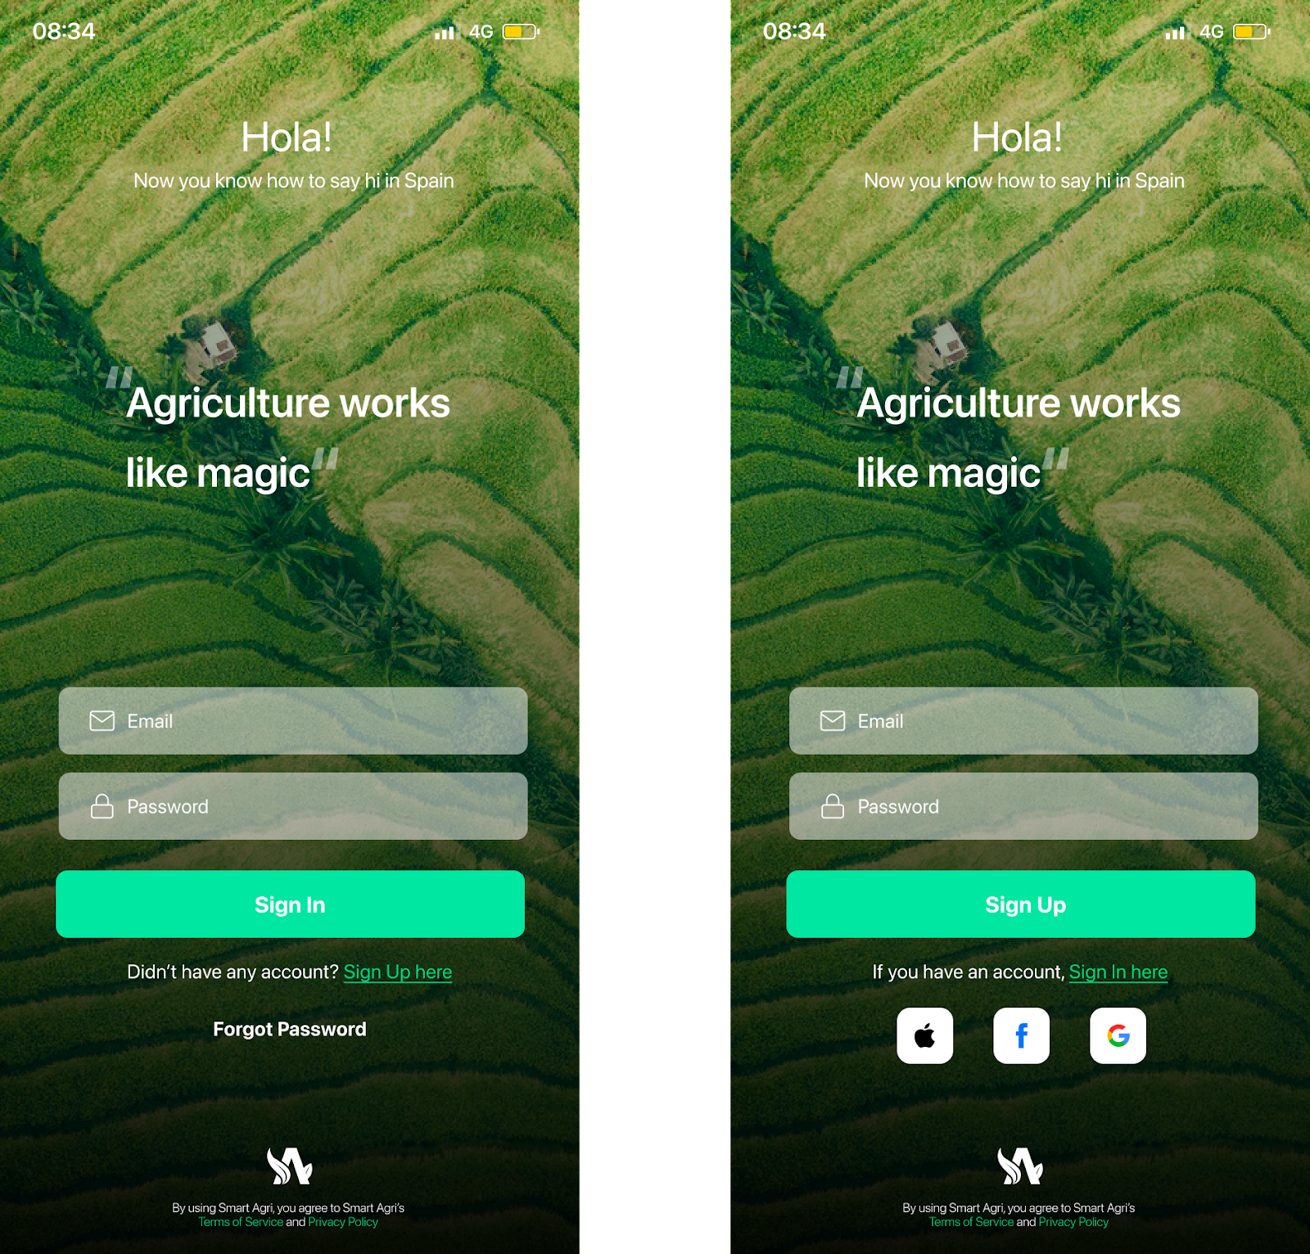A user can log in with their mail id, apple iCloud, Facebook and generate a password.

## Home Screen Service

A user can search required services, view service details and view the category and sub-category of the services.

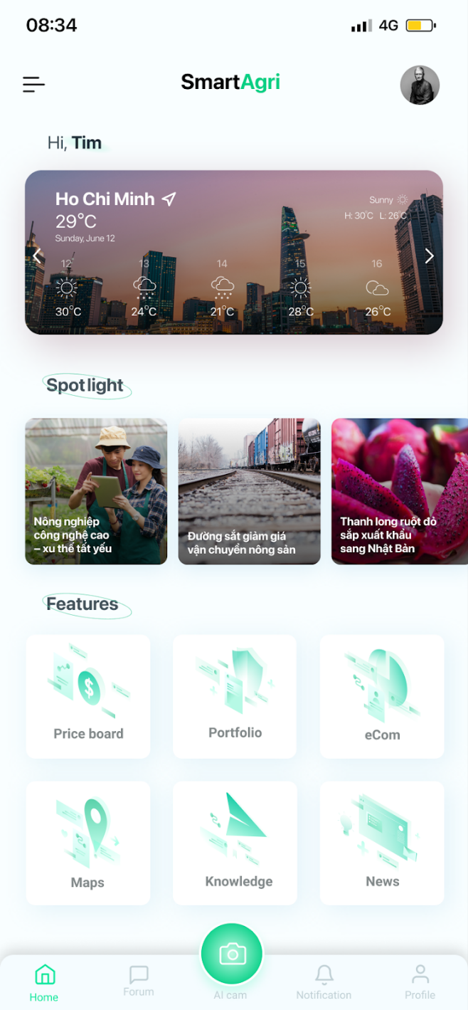

## Investment:

### Portfolio

That can see the whole dashboard where customers can view total cost value, total market value, total investment, total profit/loss, etc. With some graphics presentation.

### Price Board

The price board brings you the whole scene of the farm market, with different categories from popular to long-term or even short-term. Besides it, the price board’s sub-feature includes a piece of data of a specific farm that you can count on to decide whether to invest or not.

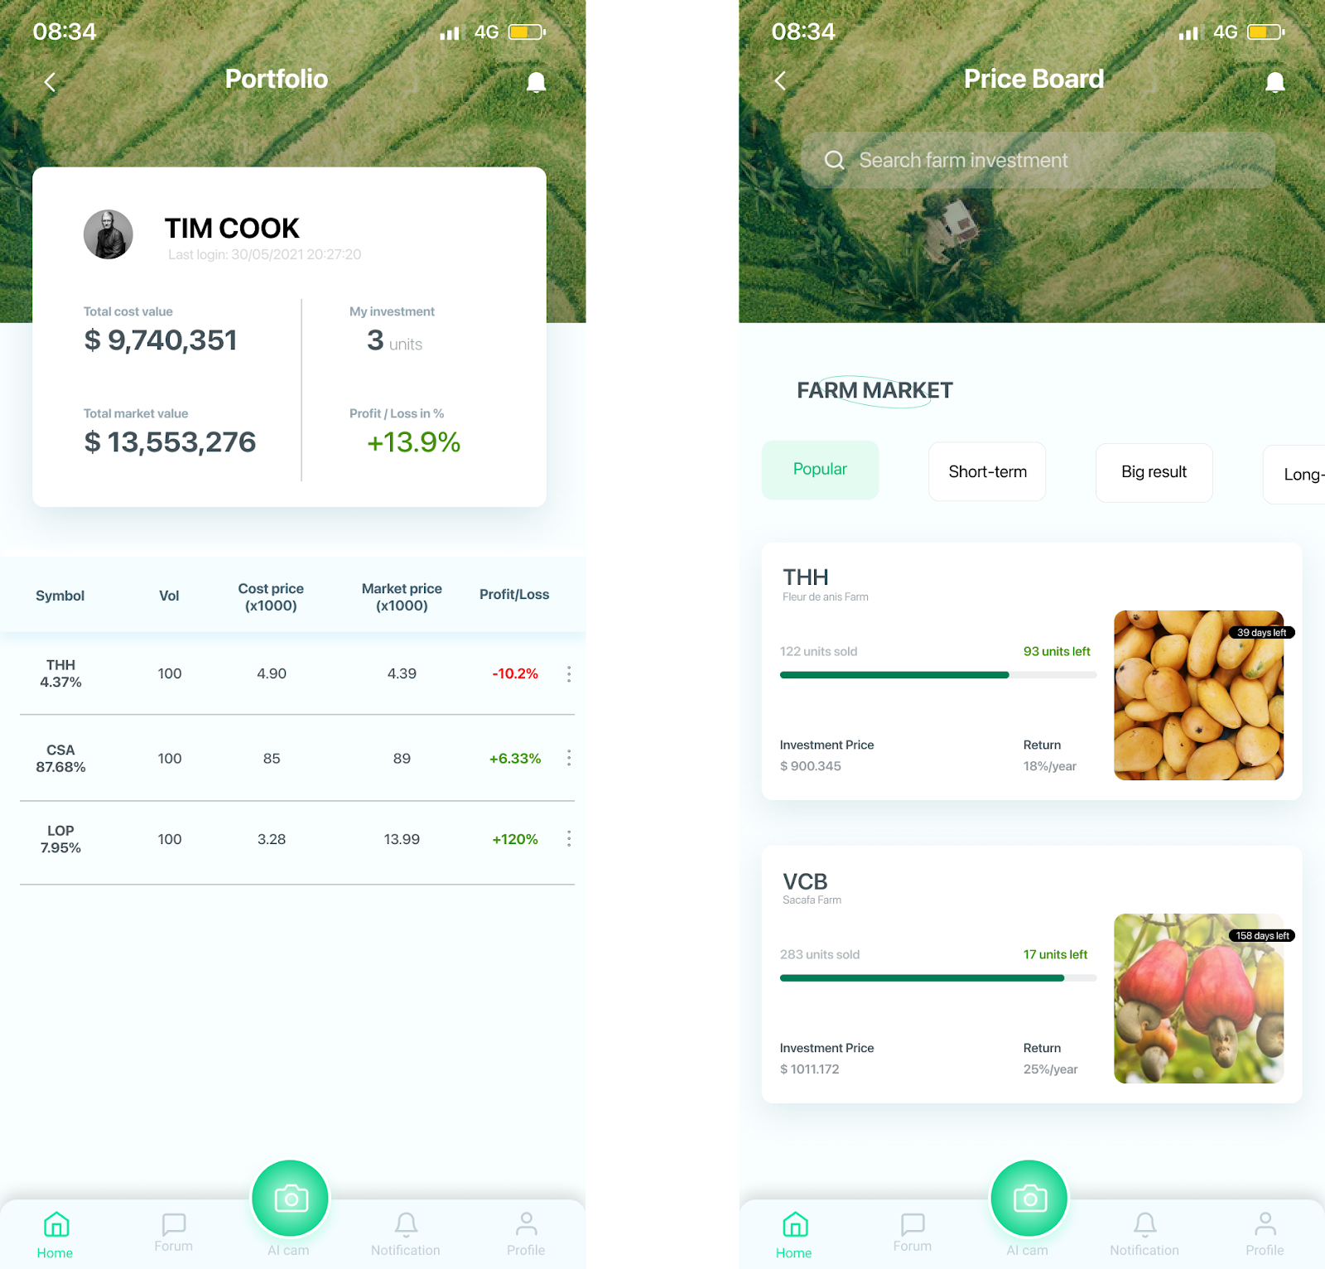

## E-Com service

Buy any fresh produce (fruit, vegetables, or rice), which are supplied from a reputation farm. With E-com service, you have lots of offers, sub-service:

### Apply Offer/Discount/Coupon:

The customer has options to apply an available couponto get a discount.

### GPS Tracking

The customer has a real-time tracking system where users can track their exact location of delivery.

### Rewards

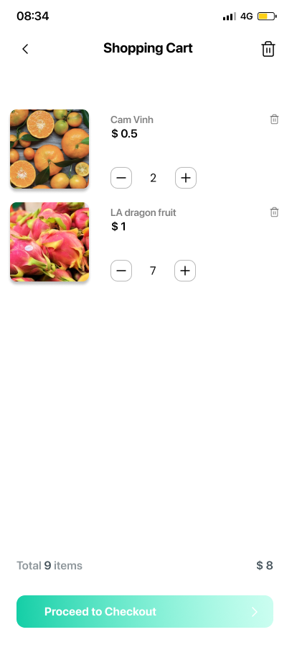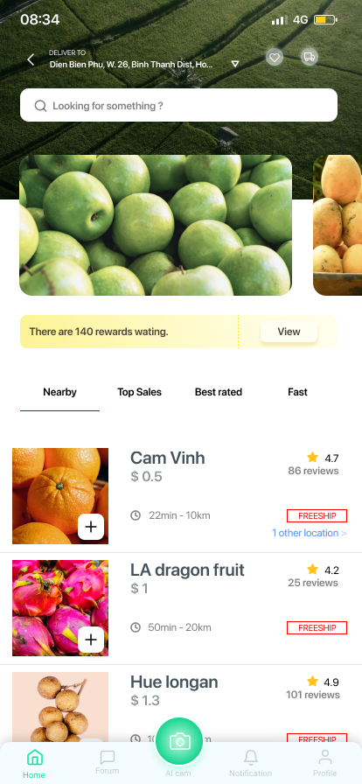Grab offers reward features to their customers with exclusive things.

## Forum/Knowledge

Bring awareness to farmers about the importance of implementing knowledge. SmartAgri also provides knowledge about agribusiness, supply chain management & experiences in applying 4.0 technology to agricultural production. Guide them chronologically on what to do during a growing season. Recommendations of processes of crop production such as:

* Soil management
* Water management.
* Cropping system management
* Fertilization
* Planting/sowing
* Crop maintenance
* Protection management
* Harvesting
* 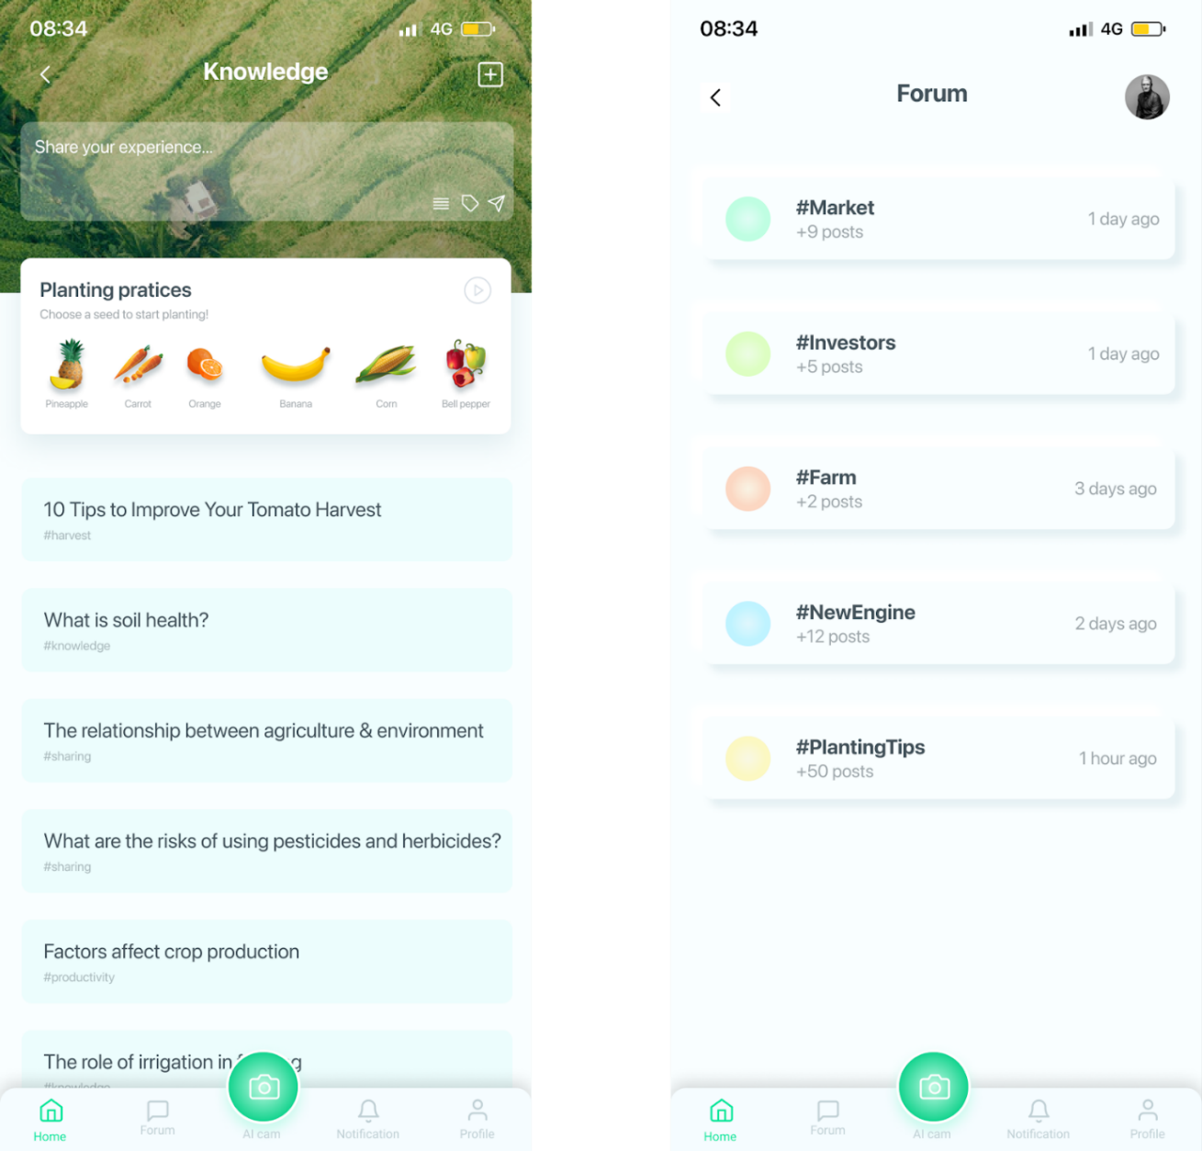Storage

## Map

Find a farm that near you, easy to track and have a whole scenario of the farm before deciding to invest.

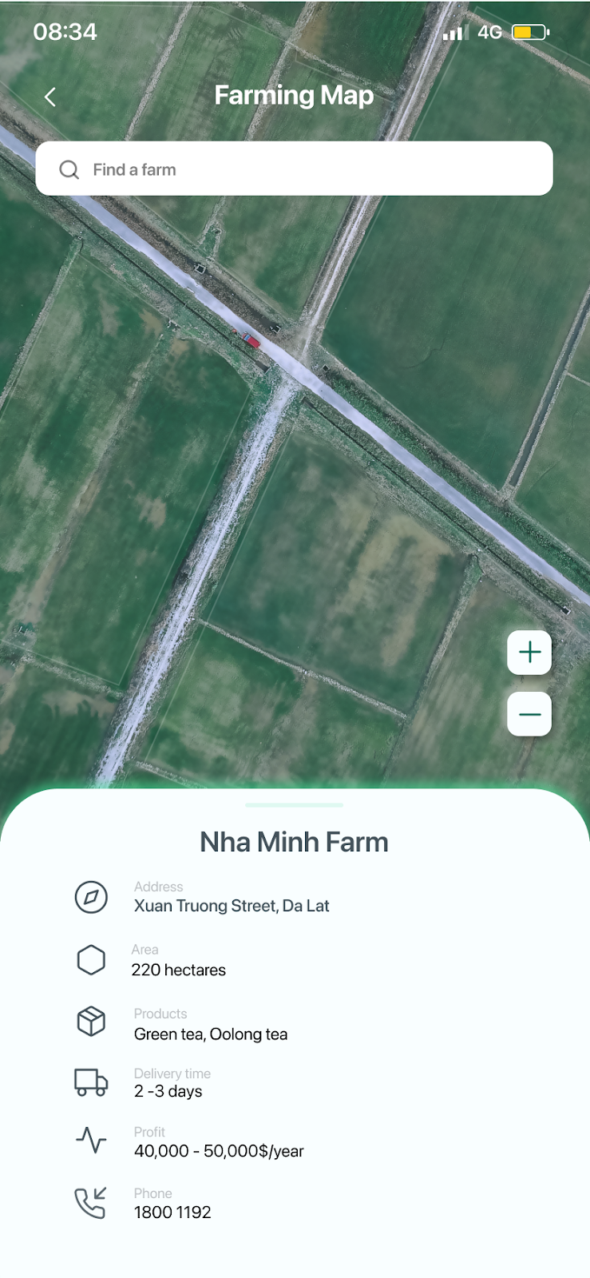

## News

Daily updates of social, economic, and commercial news, especially in the field of agriculture. There is also news about legislation, politics that directly affect agribusiness.

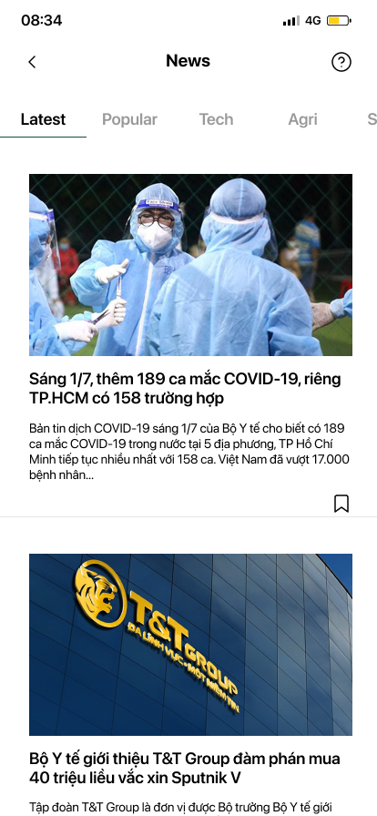

# Technical Stack

## Operating systems: iOS

iOS mobile app development is in such high demand because these applications always perform extremely well. This platform is fast, reliable, and easy to use, with few bugs remaining in the final build of any app.



## Servers and load balancing: Google Cloud

****Cloud computing today allows hardware and software products to co-exist remotely (in data centers) and at-scale. Together these products work to deliver specific services. Users typically can access, manage, and use the tools they require via a web-interface – and that's true for Google Cloud Platform services as well.

## Firebase

Firebase is a platform for web and mobile app development, including simple and powerful APIs without the need for a backend or server.



## Frontend Frameworks: Angular

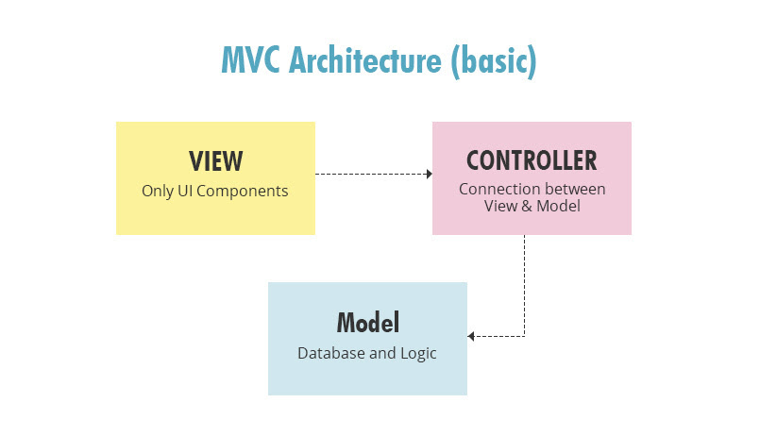Angular ensures easy development as it eliminates the need for unnecessary code. It has a simplified MVC architecture, which makes writing getters and setters needless. Directives can be managed by some other team, as these are not part of the app code.

## Monitoring and performance tools: Datadog

Datadog is a monitoring service for cloud-scale applications, providing monitoring of servers, databases, tools, and services, through a SaaS-based data analytics platform.

## AI: OpenCV

OpenCV is the huge open-source library for computer vision, machine learning, and image processing and now it plays a major role in real-time operation which is very important in today's systems. By using it, one can process images and videos to identify objects.

## Version control: Git

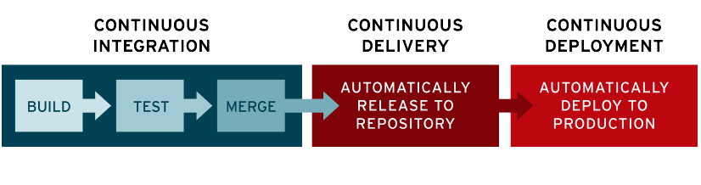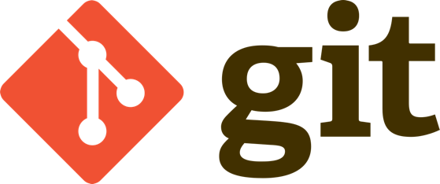Offers the distributed version control and source code management functionality of Git, plus its own features.

# Restriction and Potentially

## Restriction:

* Smart Agri lacks actual data. We tried to find many ways to collect information but none of these was successful, mostly because of Covid-19 pandemic. Because the app has a little data, we can make a mistake if the terrain, climate and soil unmatch the information we collected.
* User experience is also a minus point to Smart Agri. We don’t have many reviews from actual customers, so our app can be uncomfortable for users. Our main customers mostly are middle-aged people and a small number of young people, (Our customers are varied in ages and purposes) hence creating an UX for different types of users is really challenging.
* Although we create Smart Agri on basic and simple terms, there may be a chance that users misunderstand our features, or use it incorrectly. We want users to have their best experience using our app, but this may ruin our target. We have some solutions for this, but all of them are interrupted because of Covid-19.

## Potentiality:

* As in the report ideas, we decided to temporarily stop the implementation of IoT because of objective reasons. That is, if we have enough data from the users, our Smart Agri can be expanded to other high technology applications such as using sensors, drones or weather indicators, thus, increasing the quality and quantity of farm products.
* Ecom, or Electronic Commerce, is a creative point in our app. We have thought about an idea many times: “What if users can build and grow their own plants ?“, and we have come up with a conclusion, an Ecom. In short words, Ecom allows the users to invest in their favorite farms, and gain benefits from them, such as discounts or shares, and even plant their own seeds and take care of them, just by using phones. This allows users to have more interaction with farms, and the farms will get more investment to grow.
* AI was also a topic when we implemented the project. The group didn’t talk about it much, but everyone thought it was a good idea. We can use AI in recognizing plants through pictures, or analyzing database for a better suggestion for users,... The Dolphin believes in AI’s potential, and if we have enough time and investment, AI will sure be an important feature of Smart Agri
* User’s interaction was also a great idea when we talked about Smart Agri’s potential in the future. The technical architecture had suggested this idea, when users can have real-time contact with the farms, such as watching the growing state of the plants, or collecting information about the current weather conditions. We found this idea very interesting and creative, and it’s in our checklist for future features.

# Finance

* Manage work (sharing work, track time, contribute information,..): ClickUp - **Free**
* Sketch the idea of the app:  Milanote - **Free**
* Design UX/UI: Figma - **Free**
* Saving data, information: Google Drive - **Free**
* Conduct a meeting: Google Meet - **Free**
* Means of communication: Zalo, Messenger, Gmail - **Free**
* Resources, data researching: Google – **Free**

EVALUATION

# Assessment

## About Project

* Task management: Reasonable time for completing tasks, and every task was completed on time (**95%)**
* Work sharing: The amount of work is shared equally between members’ abilities, and each person in the team usually helps the others complete tasks. (**80%**)

## About manpower:

* Communication: Not really effective, sometimes members didn’t keep up with the conversation and the project leader had to explain twice. (**70%)**
* Leadership: The leader project works effectively, and everyone always feels motivated doing group tasks.
* Problem solving: Everyone is supportive and ready to help the others when they need (**70%)**

## About product:

Product goal: We achieved our main goals we proposed before, with some adjustments in working.

* **Analysis**: The limitations of our project was unclear at first, but after some meeting and conversation, we found the same voice.
* **Design**: Detailed and creative. The design followed the blueprint we created, with some adjustments to improve UI/UX
* **Implementation**: Following the design but flexible, the technical architecture had some minor changes to make Smart Agri looks better.
* **Evaluation**: First, we successfully implemented basic features of SmartAgri. The UI was also so a spotlight of the app, basic and modern, as we expected. UX and security were not checked, but we would look after it carefully after launching SmartAgri.

# Gains & Experiences

**Đăng Lộc:**

* Self-study to improve knowledge.
* Summarize the group's tasks and processes; defining the roles and responsibilities of team members, clarifying the team's strengths and weaknesses; Indicate rules regarding confidentiality, duties of each team member

**Phước Tùng:**

* Propose problems/solutions and act as a guide to achieve the set goals - have the basic ability of a manager.
* Deadlines increase ability to make decisions
* Learn how to use a tool

**Vĩ Khang:**

* Learn more about Vietnam's agricultural market and the applications of technology in agriculture
* Gain more experience working on a short-term project
* Increase ability to communicate, express opinions, critical thinking

**Thu Trang:**

* Know how to work on a large process broken down into small and specific phases.
* Learn how to use technology platforms, modern applications with different functions to create products
* Have a broader view of many other aspects when making a product (market demand, customer psychology, implementation costs, ...)

**Thanh Hải:**

* Conduct applied scientific research.
* Capture the law of market supply and demand

GLOSSARY

**API:** application programming interface.

**Framework:** pre-written pieces of code that form a collection of packaged programming frameworks and libraries.

**SaaS:** Software as a Services.

REFERENCE LIST

[1] [Reinder de Vries](https://learnappmaking.com/about/) ( May 12 2020). How To Make An App (In 9 Steps).

Link: <https://learnappmaking.com/how-to-make-an-app/>

[2] Proagrica. What is agriculture 4.0.

Link: [https://proagrica.com/news/what-is-agriculture-4-0/](https://proagrica.com/news/what-is-agriculture-4-0/%20)

[3] MF Tambi (November 11 2020). Emerging industry revolution 4.0 and its relationship with the agriculture sector in Malaysia.

Link: https://ap.fftc.org.tw/article/2618

[4] Aika Rey (Jan 31 2019). Grab launches 8 new app features.

Link: <https://www.rappler.com/technology/features/grab-philippines-launches-new-app-features-january-2019>